**TATA INSTITUTE OF SOCIAL SCIENCES,**

**HYDERABAD OFF – CAMPUS**

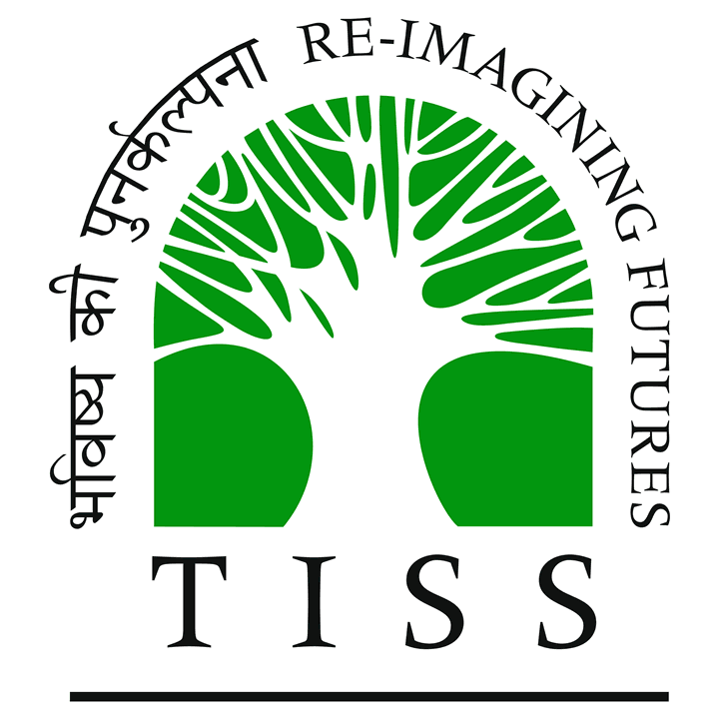

**SCHOOL OF LIVELIHOODS AND DEVELOPMENT**

**EXPERIENTIAL LEARNING – GROUP REPORT**

**Submitted by: - Group 4:**

**Asra Fatima Siddiqui (H2019DS004),**

**Dushyant Shekhar (H2019RDG005),**

**Rohit Devarakonda (H2019RDG018),**

**Salma Salim (H2019DS020),**

**Shaik Nafaz (H2019DS023),**

**Shraddha Jaiswal (H2019DS025),**

**Srinitha (H2019RDG023)**

**Overview**

The following group report on the village, Boddugonda located in Gudur Mandal, Mahabubabad District, Telangana State is a part of our exercise for Experiential Learning, which was conducted from 25th November, 2019 to 28th November, 2019 under the mentorship of the organization, Palle Srujana. We were presented with the opportunity to closely observe and study a village and its workings for 4 Days.

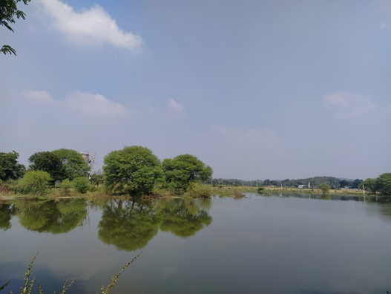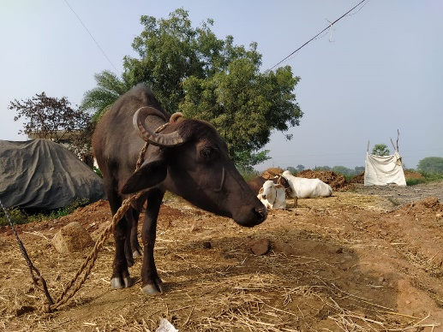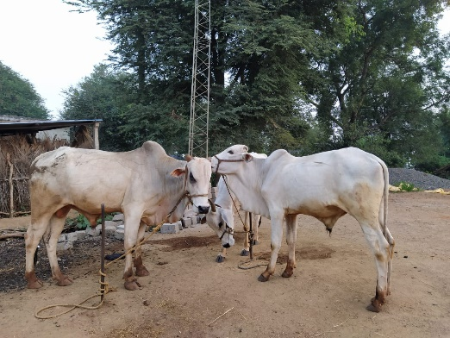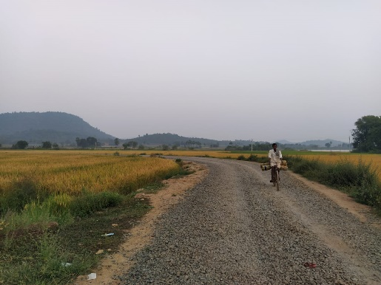

**Introduction**

The real essence of India lies in its villages. A village is a clustered settlement, basically smaller than a town and the population remains between a few hundred to few thousand. India is a country where agrarian economy has a great role to play in its GDP and accordingly, agriculture and related activities are most prominently vested in the villages of India. There is a great requirement to keep the villages of our country on the path of development since villages are roots and pillars of our country.

As students of Rural Development and Development Studies, the experiential learning in the Boddugonda village provided us with the exposure to our field related classroom learning and bridged the gap between learning and practice. As students of livelihoods and development, this experiential learning helped us to learn the rural framework along with the positives and negatives that are associated with the village settings.

The Palle Srujana organisation was the platform through which our experiential learning was facilitated and the same is the platform which provides the recognition to the innovators arising from the grass root level i.e., villages.

**Objectives**

We went to Boddugonda without any agenda or objective to pursue, thrown in the deep end of the pool and were asked to figure out what we would want to observe, study and understand about the village. To do this we came up with a few broad questions to help us in our quest to understand the various aspects of village life. The questions are as follows:

1. What are the villagers’ means to have a livelihood?
2. What is the relationship between the village resources and the villagers’ livelihoods?
3. What kind of social structure exists within the village?
4. What are the various kinds of gender related issues in the village?
5. What kind of impact the social structure has on the health and education of the villagers?
6. What kind of infrastructure was available and accessible to the villagers?

**Research Methodology**

The research methodology we used to collect data were both qualitative and quantitative. We gathered quantitative data on village population, village demographics, forest land, farm land, and non – farm land from the MRO’s office in Gudur Mandal.

We gathered qualitative data on the village experience by enquiring about infrastructure facilities (like roads, transportation, healthcare facilities, educational facilities, seed procurement centre, electricity, drinking water, water for irrigation, and other such facilities that would improves one’s standard of living), festivals, community experience, political inclinations, and other such abstract ideas.

The method through which we obtained the data was through transact walks and door to door casual interactions, focus group discussions, and comparison of narratives.

Source: Mandal Revenue Office, Gudur Mandal

|  |  |  |  |  |  |
| --- | --- | --- | --- | --- | --- |
| **Statement showing the particulars of Revenue Villages / Grampanchayats / Habitations and Thandas of Gudur Mandal** | | | | | |
| 23 | 578475 | Boddugonda | **Sl.No** | **Name Of The Habitations If Any** | **Population** |
| **1** | Boddugonda | 883 |
| 2 | Mallannagudem | 119 |
| 3 | Gollagudem | 186 |
| 4 | Chillagandi thanda | 246 |
| 5 | Errakunta thanda | 363 |
| 6 | Mudu thanda | 59 |
| 7 | Torri Kunta thanda | 60 |
| 8 | Suresh Nagar | 505 |
|  | ***Total*** |  |  |  | ***2421*** |

Source: Mandal Revenue Office, Gudur Mandal

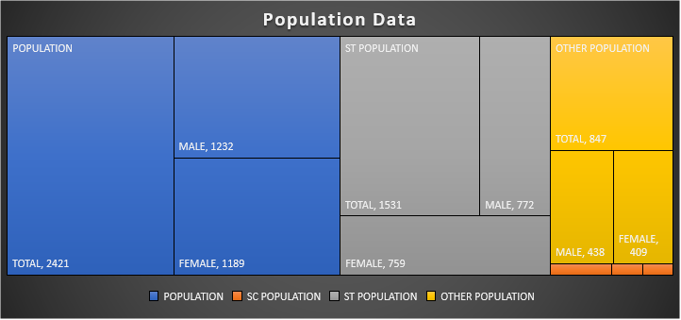

Source: Mandal Revenue Office, Gudur Mandal

|  |  |  |  |  |  |  |  |  |  |  |  |  |  |  |  |  |  |  |  |
| --- | --- | --- | --- | --- | --- | --- | --- | --- | --- | --- | --- | --- | --- | --- | --- | --- | --- | --- | --- |
| **STATEMENT SHOWING THE REVENUE VILLAGE WISE 2011 CENSUS POPULATION FIGURES IN GUDUR MANDAL** | | | | | | | | | | | | | | | | | | | |
| **STATE CODE: -28** | | | | | | | **District Code: - 540** | | | | | | | | | | | | |
| **Sl. No** | **Sub dist.** | **Town/ Village** | **Level** | **Name** | **TRU** | **No_ HH** | **POPULATION** | | | **SC POPULATION** | | | **ST POPULATION** | | | **OTHER POPULATION** | | |
| **TOTAL** | **MALE** | **FEMALE** | **TOTAL** | **MALE** | **FEMALE** | **TOTAL** | **MALE** | **FEMALE** | **TOTAL** | **MALE** | **FEMALE** |
| 23 | 04711 | 578475 | VILLAGE | Boddugonda | Rural | 633 | 2421 | 1232 | 1189 | 43 | 22 | 21 | 1531 | 772 | 759 | 847 | 438 | 409 |

Source: Mandal Revenue Office, Gudur Mandal



Land Utilization Table; Source: Mandal Revenue Office, Gudur Mandal

**Livelihood (Means and Mapping)**

When we take a village into consideration (here, Boddugonda village, in particular), the first and foremost thing that come into our minds is the people who live there, the villagers – the way they lead and sustain their life. For the life to run and the means of achieving the necessities of life for oneself (which we define as livelihood), we traced various resources and means of livelihood in this village. We found and learnt that there are various means such as (a) agriculture and related activities, (b) small scale businesses, (c) tailoring ( by women), (d) livestock rearing (goat, sheep, cattle), (e) bullocks for ploughing, (f) fish rearing, (g) auto driving, through which villagers are earning their living

(a) Agriculture – The most prominent means of livelihood is agriculture and farming activities. The produce obtained fulfils the requirements of the village. The other observation we made about the produce is that, it is not in surplus because of which the extent of the export (trade) is very less. In particular, the major crops produced are maize, paddy, turmeric, cotton, chilli and groundnut. The farmers are mostly concerned about the water availability as one of the most important inputs for the farming process, which in turn is available in satisfactory quantity. For the same, natural sources of water (i.e., rainfall, lake, etc.) are used. There is hardly any evidence of bore-well system as the cost of putting the bore-wells are high as well as the soil composition does not allow this. We also traced the government intervention of drip irrigation provided by ITDA for the ST communities. Farmers are basically poor and in turn they require loans and capital for putting various inputs into their fields. They opt for both bank and private lenders for obtaining the capital. Farmers find the bank procedures (for capital credit) difficult, as the banks ask them to go online. Also they fail to achieve instant loans from the banks. Therefore, farmers tend to move towards the private lenders who provide them credit at higher interest rate which in turn pushes them into distress. Farmers have the benefit of procuring urea on subsidies which depends on how much acre of land they own. The procurement of the produce is done in two ways, i.e., by government and by private traders. Farmers have the option to opt for the either keeping their profits in mind. The plus point of these procedures are that the role of the middle man is very less. The farmer directly sell their produce which are further stored or sent for the processing purpose.

Other than agriculture, we find livestock rearing as a livelihood in some of the communities present in the village. For example, the Yadava community is basically involved in goat and sheep rearing. The other communities like Mudiraj are involved in rearing fishes. The use of bullocks for ploughing the fields at INR 1,000 per day can also be observed. Some women are also found doing non-agricultural work like tailoring, running small shops, etc. as their means of livelihood.

a) Human capital (villagers) vulnerability

b) Natural resources (lakes, irregular rainfall,

rainfall in ample) (shocks like

c) Social capital (Yadavas, Koya) farmer death)

d) Physical capital (Mahabubabad market,

roads, electricity, public transport)

Government approaches (provision of fishes, outcomes

loan waiving, bifurcation of Telangana, *farmers came out of distress

providing tailoring machines schemes *protection to families of a

also included) farmer who dies.

*women empowerment

*better execution of

schemes after bifurcation

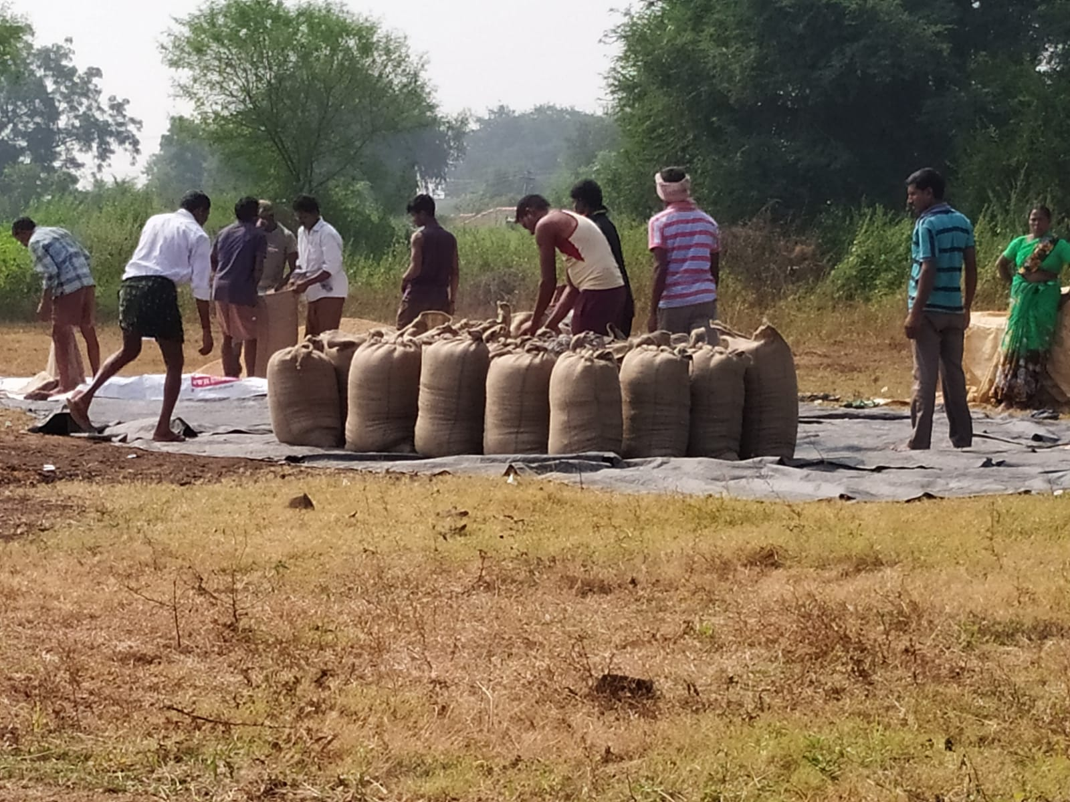

Farmers gathered for procurement

**Migration**

People have been migrating from the village over the years in search of better jobs and opportunities. We came across several instances of migration from Boddugonda. One of the instances being of the daily wage labourers who usually migrate to the district, Mahabubabad in terms of better daily wage work opportunities in industry. Secondly, the village has one barber whose shop has been displaced because of the construction of a pipeline and now has plans for moving out to Mahabubabad in terms of better opportunities. Thirdly, higher education and better jobs in cities has also always been the major cause of the new generation shifting out from the village. Then the last instance being of the Muslim families who have migrated either due to isolation or better jobs in cities. Earlier there used to be more Muslim families but now the Boddugonda village is left with only two of them.

**Basic Infrastructure**

1. The Gudur Mandal has four headquarters in terms of village panchayats with one of them being the Boddugonda village panchayat. The village panchayat is divided into ten wards with its head being Mr. M. Laxman Rao who seems to be a very infrastructure – minded person. We came to find out that he installed streetlights throughout the village with his own money. However, the village still continues to face the lack of Cement Concrete (CC) roads.
2. The village has one temple and one mosque. The mosque was built by one of the Muslim families of the village by themselves. Boddugonda village also has one rice mill which is the only mill in the village and is privately owned by Mr. Tirupati Reddy. There is also a small private library which is run by a Koya ST member.
3. In case of health related infrastructure, there is a new Primary Health Centre which has just been constructed and is ready to be inaugurated. The village itself lacks a proper hospital facility. There are two government hospitals near the village with one of them being 12 km away in mandal, i.e., Gudur and the other one being 15 km away in district, i.e., Mahabubabad.
4. There is no proper drainage system and a dumping site in the village. Lack of dustbins could be observed everywhere. Open dumping was followed even at the Sarpanch’s house who informed that the dumping site is still under construction. Usually the garbage is dumped outside which is picked up by the government truck, once every two weeks.
5. There is a problem of contaminated red coloured drinking water along with a lack of tap water facilities. Several places could be observed without taps even in the washrooms. The village has one water tanker.
6. Toilets are constructed in many houses through Swachh Bharat Mission and there were many houses who had constructed toilets even before the scheme was implemented. However, such houses too received a reimbursement of amount INR 12,000 each. Still there are many houses which do not have a toilet and even if they have, they do not have tap water which is why signs of open defecation can still be observed.
7. The Boddugonda village has one government school which is till class 8th. The school lacks basic infrastructure because of scarcity of funds. Only 5 rooms are available in the school building which is why the classes need to be taken outside the classrooms. There is no separate building or even a separate room for Aanganwadi. The washrooms constructed in the school are not at all in a useable condition and students have to go out in the open to defecate.
8. The village also lacks a proper banking facility. There is no bank or ATM in the village. However, signs of G-pay and BHIM UPI QR codes could be observed at shops near the main road and inside the village.
9. There are twenty-four Self Help Groups functional in the village. They are just meant for women and consist of ten women each. They teach different things to women like teaching, weaving, making processed food or any other activities that the women may be interested in. They also help the women get wage labour jobs if required.

**Education**

In village Boddugonda, the total literacy rate is 43.9% (1,063) according to the 2011 census.  
• Female literacy rate is 18.5% which comprises of 447 female population.  
• Male literacy is 25.4% which comprises of 616 male population.

Boddugonda village has UPS (Upper Primary School) but no ZPHS.  
• School has classes till 8th standard and English is taught only till 3rd. It has a head master and six teachers who stay at nearby places such as Mahabubabad and Gudur.  
• School has 5 rooms and anganwadi also functions in the same building.   
• Total strength is 58 including 25 girls and 33 boys.

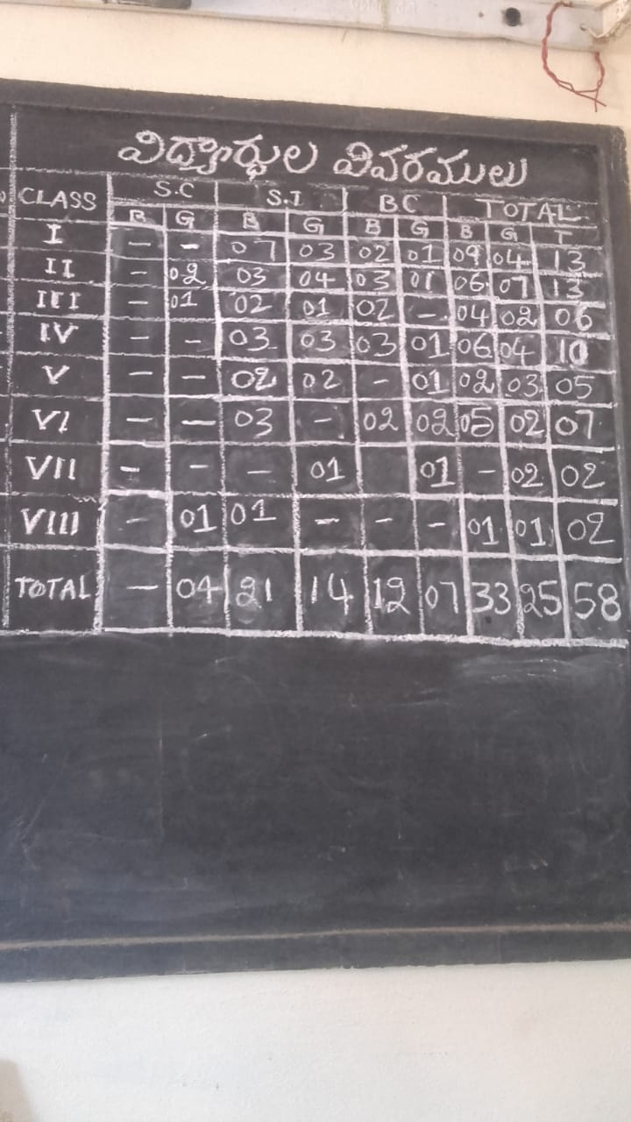

Details of students studying at primary government school of village on a blackboard inside staff room

• Majority of the students belong to the ST, SC community and then followed by BC community. No OC community student is studying in government school.  
• Government provides two pairs of uniform and text books each.  
• No stationery is provided by the government.  
• Students of different classes are taught in a single room with some students even being taught outside the classrooms.  
• Mid-day meal program is implemented and INR 6 per child is allocated. The INR 6 allocation by the government includes the cost of vegetables, eggs, and the input cost of mid-day meal makers. Rice bags are provided by the government. The menu includes boiled eggs, nutritious food. Three boiled eggs are provided once in a week.  
• School washroom is not in a useable condition thus, forcing the students to go for open defecation. No proper action has been taken to improve the condition of the washroom. The washroom has not been used since the past three months.  
• Problem of water filtration during the monsoons is solved by filling sand to level up the road. Because of the non-availability of proper playground the sports activities are not properly conducted. Most of the villagers belonging to OC category are sending their children to private school because of lack of proper care in government schools.

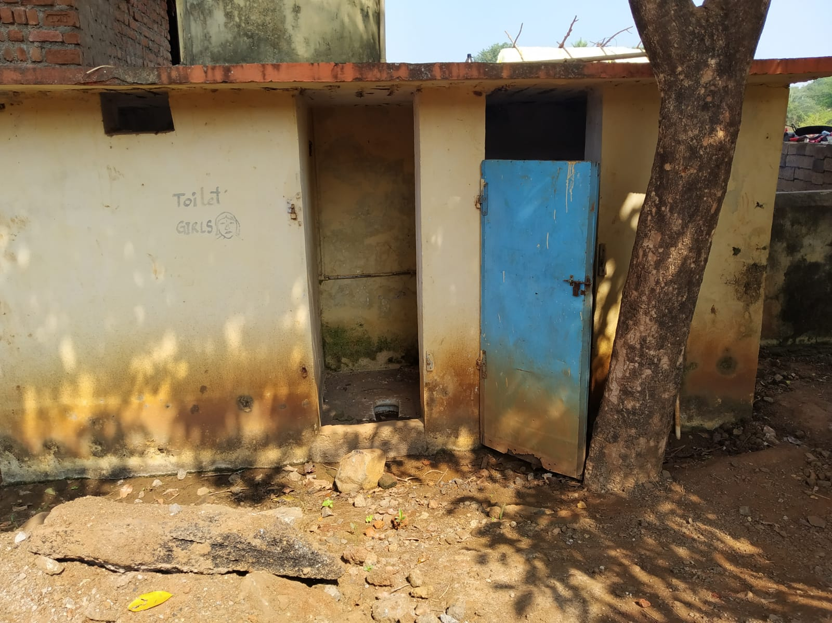

Washrooms of primary government school in unusable condition forcing the students to defecate in open fields nearby

There are no drop outs from school. Mostly no gender discrimination can be seen in the village. The girls are encouraged to study and been sent to school. Married girls are also interested to continue their studies. And usually the families can also be observed to be supportive.

School gets INR 15,000 per year as fund to conduct the events like Independence Day, Republic Day, Children’s Day, etc.

The aspirations of children for their village are availability of a:

* high school with a playground,
* park/zoo,
* theatre,
* a temple,
* and roads, etc.

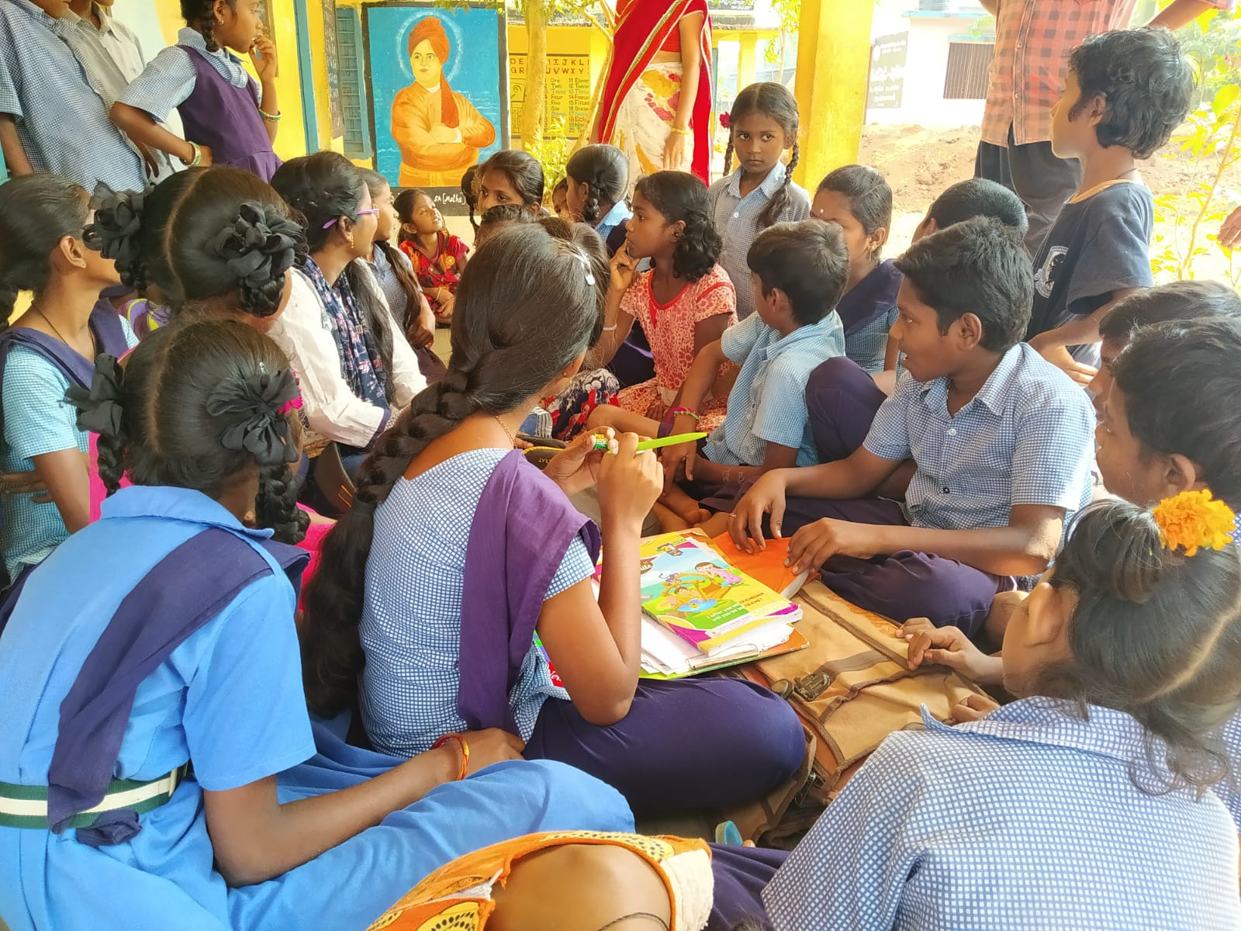

Students of all classes interacting with our group members

**Aanganwadi:**

There is one aanganwadi centre in the village. There are 22 children and 6 pregnant women in the village. Aanganwadi centre is located within the school building in a room. It has 2 workers in it.   
• A nutritious food Balamrutha is provided to children and boiled eggs are also provided.  
• Milk and eggs are provided to pregnant women.  
• Basic elementary education is provided to kids.

Sometimes if the funds get delayed by the government, aaganwadi collects the funds from the donors. If no funds are available then they invest the amount themselves and later they get a reimbursement.

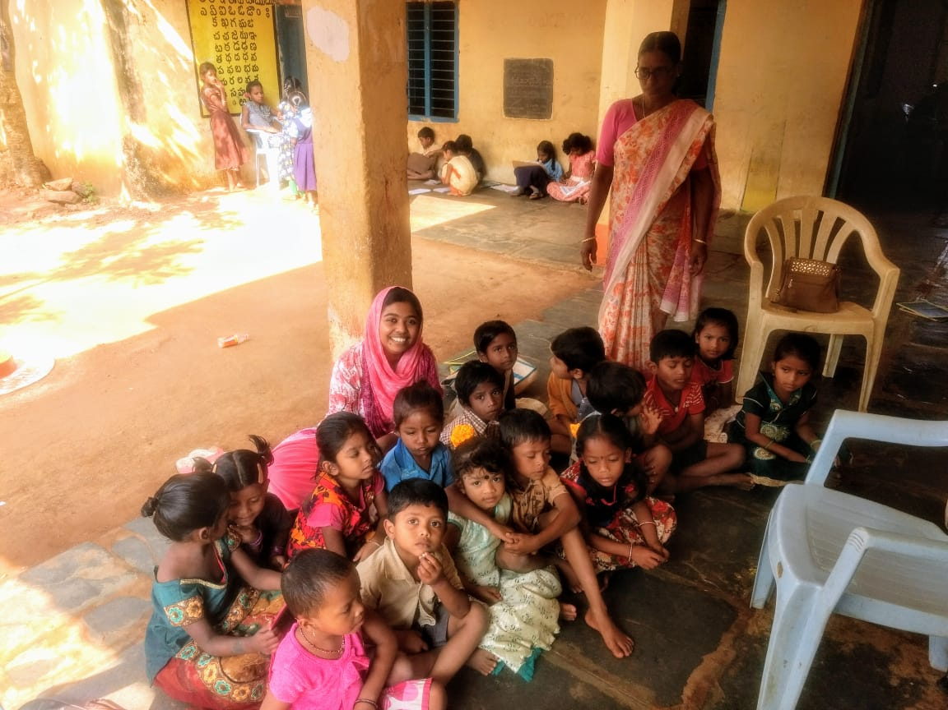

Aanganwadi students

**Health**

Health conditions of Boddugonda Village are such that the villagers are facing a lot of hygiene issues due to the unhygienic condition of the village.  
• There are 3RMP's in the village. RMP’s are charging minimum charges for services like injecting the injections, etc. No consultation fee is taken by them.  
• Major diseases in the village are such as viral fevers, allergies, etc.   
• Most of the people are diabetic and suffering BP problem.  
• Government hospital is 15km away from the village. Ambulance facility is provided but it is inefficient.

• The allergies are mainly caused by the usage of Bhagiratha water.  
• Pregnant women are facing problem due to the non-availability of hospital.  
• Open defecation is a major issue.  
• Due to the problem of washroom in school students are going for open defecation and in turn facing hygiene related issues.  
• PHC was runned in a rented room earlier; now a new PHC has been constructed but yet to be inaugurated. ANMs frequently visit the village and basic health facilities are provided.   
• A new construction of a dumping site and a graveyard is about to come in the village.

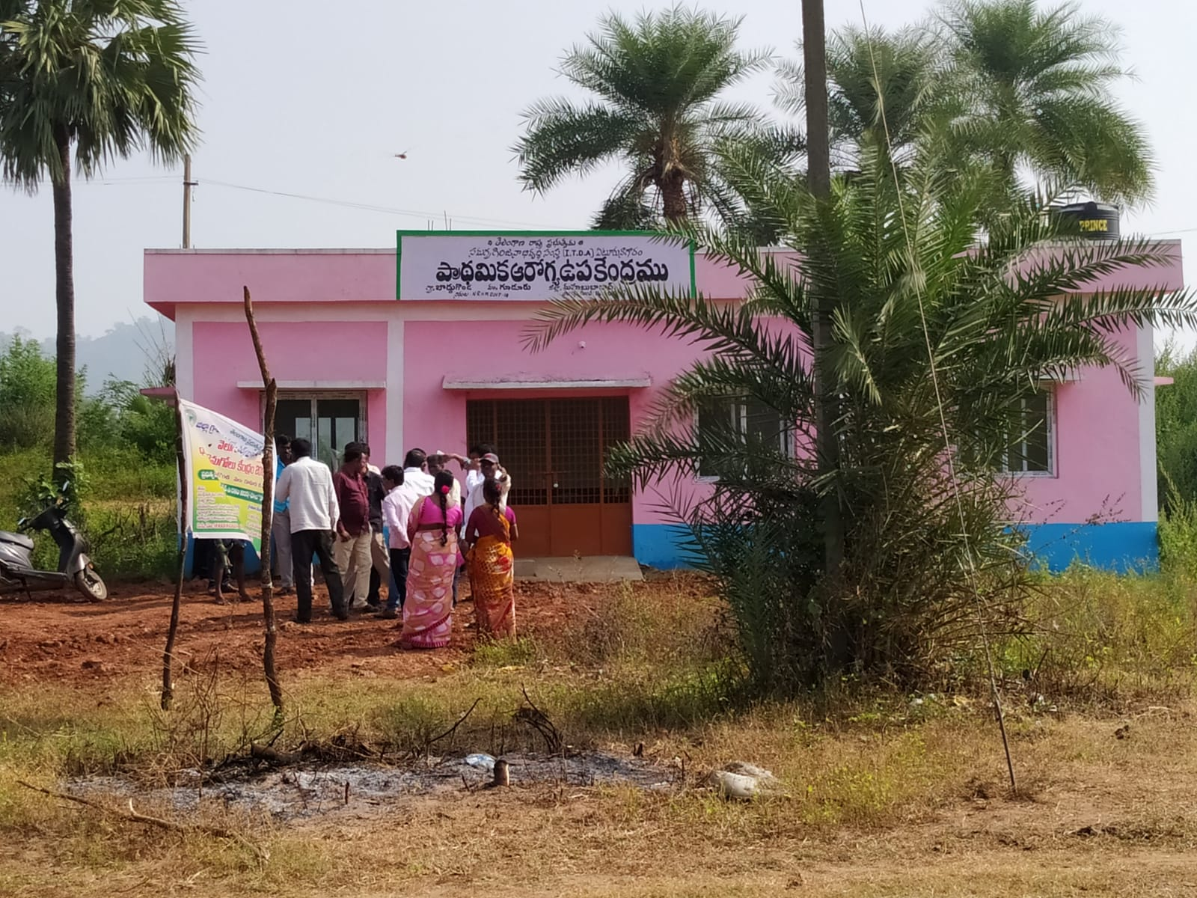

Newly built Primary Health Centre

**Political Structure**

The politics of the village is immediately identified as the power being exercised by certain individuals of the village. Each community has a senior individual, colloquially called as the community headman. They enjoy the power to determine instructions and govern the life of the people in their respective communities. However, these community headmen are entitled to obey a common village headman who belongs to the Rao community. The appointment to these positions have been mostly observed to be hereditarily passed and submissively obeyed.

The Sarpanch of the village exists in harmonious relationship with the common village headman. The villagers follow the community headman system. Matters of concern or complaint reach the Sarpanch only after being moved by village headman. Both belong to the social group called Rao. Any important decisions to the village happen only as an agreement between the community headman and the Sarpanch.

The Sarpanch was nominated to his position, without the conduct of an election. He stated it as a unanimous decision of the village. However, many of the villagers have confessed that they did not have any role in the matters of politics but adhere to the instructions of their community headmen.

The village become politically active only during the elections. The village has two polling booths. As per the Sarpanch and the Mandal Revenue Officer (MRO), the polling of the village is closely near to 90% of the village population. But, as already said, the majority of them are deprived of the autonomy to choose for their representative. The MRO’s office is in charge of ensuring the enrolment of every adult of the village in the voter’s list. The office is also responsible for monitoring the election processes and ensuring a fair conduct of the same.

The village is free of the competition between the political parties. TRS is the major political party of the village. It is then followed by the Congress. But, the presence of political party is closely tagged to the interest of the powerful people of the village. That is, the Sarpanch had belonged to the Congress a few years ago. He was elected to power with a winning majority of the Congress. But years later, he announced his support to the TRS. The election result then maintained the political status of the current Sarpanch. Hence, it is apparent along with the time that the political power of the village is invested in certain persons. Neither the party, nor the ideology is seen to be existing in the village.

The presence of the Communist Party of India (CPI) is almost negligible. Despite being a village which is predominantly dependent on the agriculture, the CPI is a forgotten story of the village. The CPI had existed in the village, several decades ago. It protested against the feudalism in the village. The dissatisfaction amongst the peasants and daily workers gave rise to Naxalite movement in Boddugonda. It resulted in an encounter of the leaders of the movement, remembered as Com. Suresh and Com. Madhav. The CPI ceased to exist along with the decease of the leaders.

The village exhibits traits of gender equality aligned to the political power. The village has a total of 10 wards out of which there is equal representation from both the men and women. The village also has a history of having their last Sarpanch a female, named Ms. Suchitra. All the women are free to attend the Gram Sabha. But the decisive power is not evidently distributed among the genders.

The Gram Sabha welcome inclusiveness to the villagers. But, majority of the village population had not been attending the Gram Sabha. They could not afford to leave their labour for survival. Also, it is important to note that invitation to attend does not correspond to the decisive power. According to the oral sources, the Gram Sabha operates on the powers of the elected members and the community headmen, especially from the upper castes.

The Panchayat Office rarely opens in the village. It depends on the interest of the Panchayat Secretary. He possess the key and opens the panchayat office according to his convenience. Interestingly, the male members of our group were offered their stay at the panchayat office. Thus, there is an evident uncertainty and negligence in the working of the federal institution of the village.

Nepotism could be easily experienced at the village. The aanganwadi teacher is a sister of the Sarpanch. She was recruited without any formal proceedings. Also, few of the other well-off families share their immediate relationship with the Sarpanch. For example, a household having more than ten acres of land, and the financial ability to buy a new tractor without any loan, have family bond with the Sarpanch. Besides, the installation of streetlights and the presence of shops and services dominantly surrounds the Sarpanch’s house.

Politics is clearly not an every-day affair for the villagers. The village continues to have a semi-feudal structure. The political awareness among the people is sparingly minimal. For example, few of the villagers wore t-shirts that were campaigning for the Bhartiya Janata Party without knowing about the person or the party that the t-shirt campaigns for. Also, the political parties seldom show their existence by conducting rallies for some random reason. Hence, the political structure of the Boddugonda village is apparently vertical and caters to the interests of the upper strata.

**Government Schemes and their Implementation**

We tried to analyse various central and state government schemes implemented in the Boddugonda village through interaction with the villagers and various government officers such as Sarpanch, Tehsildar, etc. There were 3 major questions in our mind while we were collecting the information about government schemes and its implication. The questions are as follows:

1. What are the major government schemes implemented in the village?

2. Who are the beneficiaries of the major schemes? How the beneficiaries are being selected by the government officials?

3. What are the constraints in implementation of the schemes?

Interacting with the villagers and the Sarpanch we came to know about the various central government schemes and the flagship programmes of state government of Telangana. The schemes are as follows:

**1. Indira Aawas Yojana (IAY)/ Pradhan Mantri Gramin Awas Yojana (PMAY-G)**

Indira Aawas Yojana is a rural housing programme started in January, 1996 by the then Prime Minister, Rajeev Gandhi with a mission to provide housing for rural poor in India. The cost of unit assistance is to be shared between central and state government in the ratio 60:40 respectively. In 2005, this scheme got renamed as Pradhan Mantri gramin Aawas Yojana. We observed a gap in the implementation of this scheme since for more than hundreds of applications received by the panchayat office for the last four year no houses were built through this scheme. The constraint in implementation of this scheme is lack of funds.

**2. Pradhan Mantri Gram Sadak Yojana (PMGSY)**

Pradhan Mantri Gramin Sadak Yojana was launched by the government of India to provide rural connectivity to unconnected habitations as a part of poverty reduction statergy. We observed the construction of the roads going on under PMGSY scheme.

**3. Swachh Bharat Abhiyaan**

Swachh Bharat Abhiyaan is one of the flagship cleanliness programme of Narendra Modi led central government. Elimination of open defecation is one of the aims of the programme. We observed most of the underprivileged sections in the village doing open defecation. We came to know that the individual households build their toilets and the panchayat reimburses the fund when the toilets construction work is completed. Most of them being agricultural labourers they do not have enough money to invest in the construction of toilet. This is one of the constraint in implementing the construction of toilets.

**4. Mahatma Gandhi National Rural Employment Guarantee Act (MGNREGA)**

MGNREGA is an Indian labour law and social security measure that guarantees the right to work. It aims to enhance livelihood security in rural areas by providing atleast 100 days of wage employment in a financial year to every household. In Boddugonda village, under this scheme most of the women are employed in cleaning the ponds and other water bodies.

**5. Mission Bhagiratha**

This is one of the flagship programme of Telangana state government to provide safe and sustainable piped drinking water supply from surface water sources. Through interacting with the households we identified under this scheme, each household is provided with piped drinking water. We also observed some villagers illegally using the water for agriculture and its allied activities.

**6. Rythu Bandu Scheme**

Rythu Bandu Scheme is a welfare programme of Telangana state government to support farmers’ investment for 2 crops a year. The government is providing 5000 rupees per acre per season. We observed that this scheme is benefiting only the land owning farmers. Even though most of the land owning farmers are giving their land for lease they are getting 5000 rupees per acre per season. The landless agricultural labours are again marginalised through this scheme.

**7. Telangana Integrated Fisheries Development Scheme (IFDS)**

IFDS is one of the welfare programme implemented by the state government of Telangana for the fisheries development. Interacting with the Sarpanch we came to know that under this scheme, the panchayat is providing subsidies to inputs of fishing communities. High quality nets and fish breeds are given to the farmers at subsidised costs.

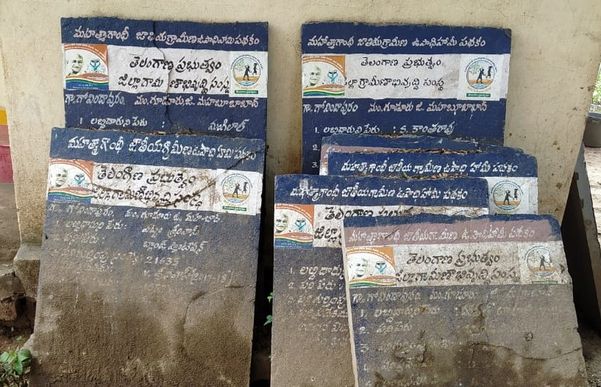

MGNREGA boards found outside a Harijan’s woman house

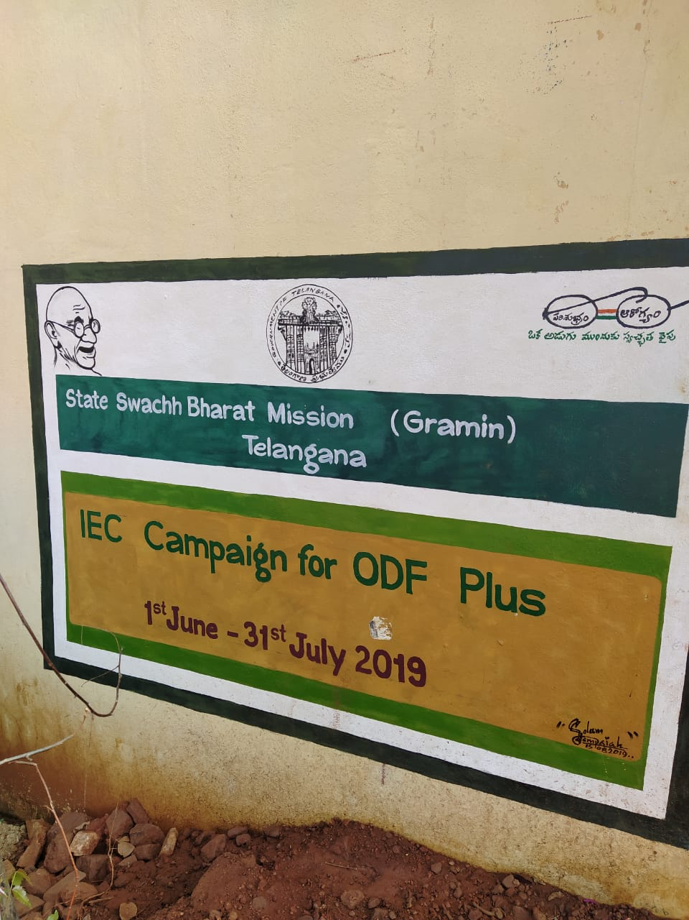

Swachh Bharat Mission painted outside a school wall

**Social Structure of Boddugonda**

In the village Boddugonda, different caste based communities and settlements can be observed involved in various livelihood activities. These communities come under the three broad categories of ST (Scheduled Tribe), BC (Backward Category), OC (Open Category) with OCs being higher up on the terms of socio-economic ladder. The caste composition and caste based occupation of village is elaborated upon in details below:

1. **Scheduled Tribes**
2. Koya Tribals (approx. 150 families)

Recently assimilated in the village of Boddugoda (around 30-40 years ago), this community was largely involved in subsistence agriculture in the forest area. After being assimilated in the village, a lot of the community members took up wage labor as well as small scale farming. Literacy rate among the older generation of this community is very low however the younger generation is doing relatively better in terms of education.

1. Lambada Tribals

The ancestors of this community came from Rajasthan to sell textiles and carpet and some of the family settled in the village over time. Among the Koya and Lambada communities, Lambada have relatively higher literacy rates.

1. **Backward Categories**
2. Yadav

This community has traditionally been rearing goats as a means of their livelihood. This can still be observed in the village as the families belonging to this community still rear goats.

1. Gouds

At present some members of this community are involved in farming as well as traditional palm wine/ toddy tapping

1. Mudiraj

This community derives its livelihood sustenance mostly from fisheries but in this village they are involved in farming as well.

1. **Open Categories**
2. Reddy
3. Velma
4. Rao

Apart from this there were two Muslim families living in the village involved in service providing activities like electrician work, auto rickshaw driving, etc.

**Social structure in relation with Education, Health, Resource ownership and Politics**

1. **Education**

It was observed that no family belonging to OC send their children to primary government school in the village. Only students belonging to BC and ST categories are studying in the village school. Muslim and upper class BC families also send their children to private schools in the district Mahabubabad (15km away). The condition of primary school in the village, quality of education provided, and affordability of private schools by the upper caste and upper class can be the reason attributed to this observation made in the village, Boddugonda. There was no discrimination on the basis of gender observed in terms of primary education. However, there were many cases of girls dropping out after high school due to primarily two reasons viz. marriage and unavailability of higher education institutes nearby village. Many families do not feel it’s safe for the girls to travel so far for the higher education which has resulted in the parity between education between girls and boys of the village.

1. **Health**

Major health issues observed in the village were of skin allergies and infection because of the contaminated red coloured water. However, we observed that most of the families belonging to OC had filters installed in their homes and the contaminated water problem was prominent in SC colony only.

1. **Resource Ownership**

We observed that most of the land resource in the village was owned by upper caste people belonging to OC. On an average they held ancestral land ranging from 5-15 acres and in some cases even more than that. On the other hand people belonging to BC held land ranging from 2-4 acres along with the land titles in most of the cases. People from ST community held the least amount of land ranging between ½-2 acres. Most of these people do not have “patta” or land titles and only a few families have started receiving the land titles recently.

1. **Politics**

Party politics does not play an active role in the village. Most of the political power is exercised by some people predominantly belonging to upper caste like Reddy, Rao and holding majority of the land resource in the village. Invisible hand in political power could also be observed wherein people approach a certain authority figure before approaching the Sarpanch of the village.

Election of Sarpanch had contrasting views form members of different communities. Some people said the Sarpanch was elected unanimously without any contest, however, some people (daily wage workers) pointed out that a few powerful people in the village decided to elect him as Sarpanch.

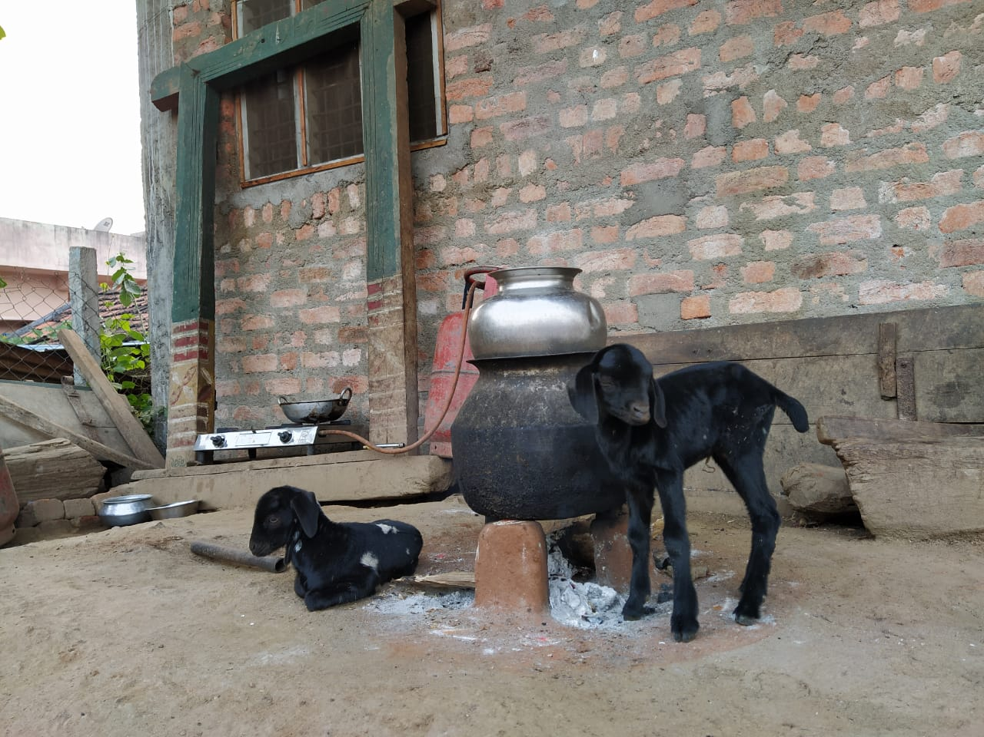

Goats at the house of a family belonging to Yadav community

**Conclusion**

This experiential learning was a lifetime experience for us. We got exposure to a lot of rural realities that we had just known of in theory. Studying about villages, villagers, their livelihood and development in our classrooms is different from experiencing it all on our own. Though we all felt that four days was a short span of time to know about it all very closely but still all the information and knowledge that we managed to gather helped us in bridging the gap between our classroom learning and the ground reality.

Through our observations, face-to-face interactions, and focus group discussions, we observed that a sort of a social structure in terms of caste and gender but it is not too much persistent. We were happy to find that women were talking to us as freely as men while in few households we also observed married women hesitant in talking to us as freely as others because of the fear of their in-laws. This suggests that yes, some sort of hierarchy does exist in this village but it is not that persistent. Apart from this, all the villagers that we interacted with, especially, the daily wage labourers, we found livelihood to be their major concern. While on one hand we found absolutely satisfied people, on the other, we also found, for example, a fiery lady who was filled up with anger due to all the hardships she is going through in her village.

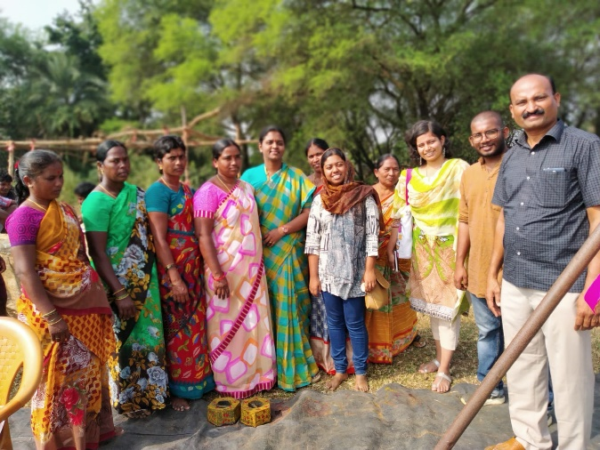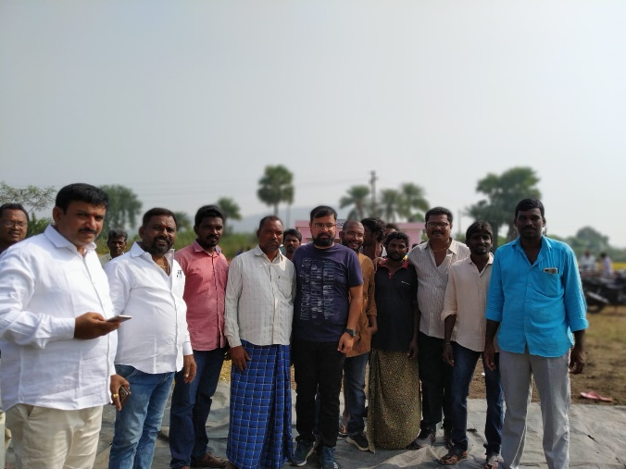

1st picture L to R: our group members with Zila Parishad Territorial Constituency member

2nd picture L to R: our group members with the Sarpanch and few farmers

Overall, this experiential learning played a very important role in our academic life since it ensured that we take back something to remember and apply when we step out into our professional life. It made us unlearn about the pre-conceived notions about an Indian village only to learn again through experiencing the reality. We thank Tata Institute of Social Sciences, Hyderabad and Palle Srujana for providing us with this unforgettable and enlightened experience.